

G-30, Inavolu, Beside AP Secretariat Amaravati, Andhra Pradesh-522237

**STUDY ASSISTANT**

## ABSTRACT

Students tend to get carried away and distracted easily while studying. This problem is common with all children and especially children with ADHD (Attention-Deficit/Hyperactivity Disorder). When they go unmonitored, children are prone to pretend to be studying or doing other activities. Many sleep during their study session. To overcome the problem of children going unsupervised we have come up with the idea of "Study Assistant". The concept is to monitor the child during the study session and nurture them with the care that they require to be motivated and noticed. Our project would detect the face of the person and their eyes to alert them if it's closed for a long time which will also ensure that the person is present there physically. It would alert them if their body posture seems to be bad or in an unhealthy manner, remind them to take sedentary breaks and water breaks, and record the session timing from start to end to keep track of their goals. The functionality of the project as a whole prototype was built and successfully executed to give the desired outcome. Each function module was integrated into Raspberry Pi along with hardware components such as the camera, LCD screen, buttons, and speakers to make the product work as expected.

# INDEX

|  |  |
| --- | --- |
| **1** | **Introduction** |
| **2** | **Objectives** |
| **3** | **Methodology** |
| **4** | **Results** |
| **5** | **Conclusion and Future Scope** |
| **6** | **References** |

## 1 . INTRODUCTION

1.1) If you’re okay with killing time, it’s not scarce enough. Time is scarce, life is short, and as the grains of sand slip through the hourglass, so does the precious gift of time. Once gone, it disappears forever. We all know these things. And yet, at work and home, we’re so lost in a trance of distraction that killing time has become a chronic disease. 1.2) Much of modern leisure is slothful. It’s spent in a state of passive, shoulders-slumped consumption where we inhale processed foods that make us fat, TV shows that numb instead of inspiring, and advertisements that create anxieties that only shopping can relieve. The lethargy of modern leisure says that movement is tyranny as if humans are batteries to be recharged by the electricity of mindless entertainment. 1.3) How many times have we sat down to study, only to scroll Instagram the next minute? Living in a generation where we get endless entertainment in a couple of clicks, it's an arduous task to focus on one thing for a long period of time. 1.4) How many days breeze past only for us to realize, we haven’t done what we set out to do? Even if we make up our mind and sit down to focus, we often overlook our bad posture, which may be detrimental to our health. Keeping ourselves adequately hydrated is also imperative. In short, we need study etiquette, a collection of good study habits, like planning ahead and keeping track of our progress, etc. This is exactly what we aim to solve with Study Assistant. 1.5) Study Assistant is your personalized study buddy with an inbuilt Pomodoro timer, which helps you to schedule your work and keep track of your progress; posture corrector, which gives a prompt if your posture is not ideal; and also reminds you to take frequent water breaks to keep you hydrated. Whether you are a parent worried about your child’s study habits or a person who needs a nudge to get the ball rolling, Study Assistant is the right fit for you.

## 2. OBJECTIVES

2.1) The main objective of the project is to help the students stay awake and be centralized while studying when no one is present to monitor them. 2.1) To build and device that will detect their face and alert them to correct their posture if seems bad and unhealthy. 2.1) To record the progress and the duration of their study time and collect a log of the data when they are unsupervised. 2.1) To ensure that they are nurtured with the care that they might have when being monitored and remind them to take necessary sedentary breaks to keep them stress-free. To notify them about their progress to keep them positive and motivated

## 3. METHODOLOGY

3.1) The project provides the following real-time support:

* + Duration of study time
  + Posture monitoring and alerts
  + Sedentary break reminders
  + Hydration reminders

3.2) Two buttons are used for user inputs to begin and end sessions.

3.3) A camera captures video feed to monitor face presence and posture.

3.5) A 20x4 LCD screen displays messages and prompts.

3.6) A buzzer or LED provides alerts for posture or reminders.

3.7) Posture detection is based on the vertical position of the user's head in the frame. If the centre of the face is detected below a threshold line, an alert is triggered to encourage posture correction.

3.8) The system maintains logs for the number of posture alerts and water break prompts during each session.

3.9) Audio feedback (beep/voice) is added to improve user response to posture corrections and reminders.

3.10) A real-time timer is displayed on the LCD to help the user remain aware of their session progress.

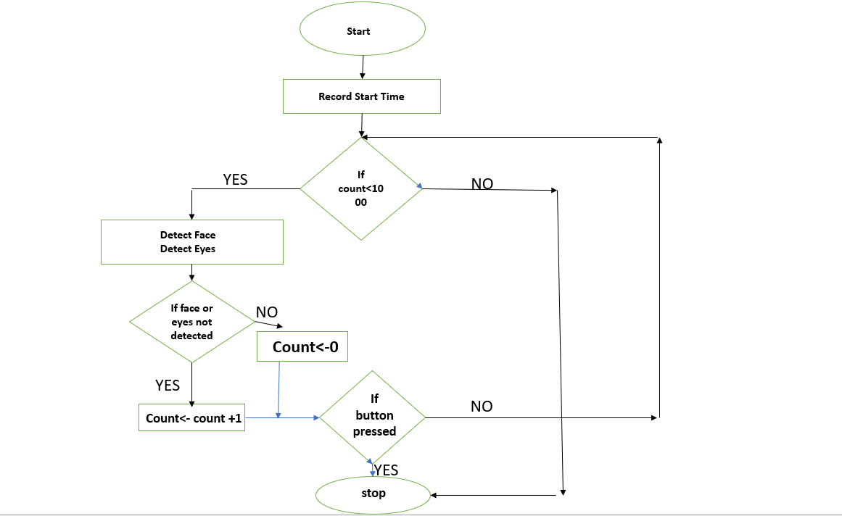

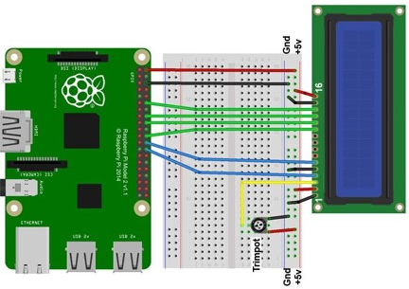

**4. RESULTS**

4.1) The improved system not only records eye activity and posture but also logs the number of times the user received alerts or reminders. This helps analyze how often the user loses focus or maintains poor posture. The inclusion of an optional voice/audio alert and a live LCD session timer enhances interactivity, making it more engaging and effective for long-term study improvement.

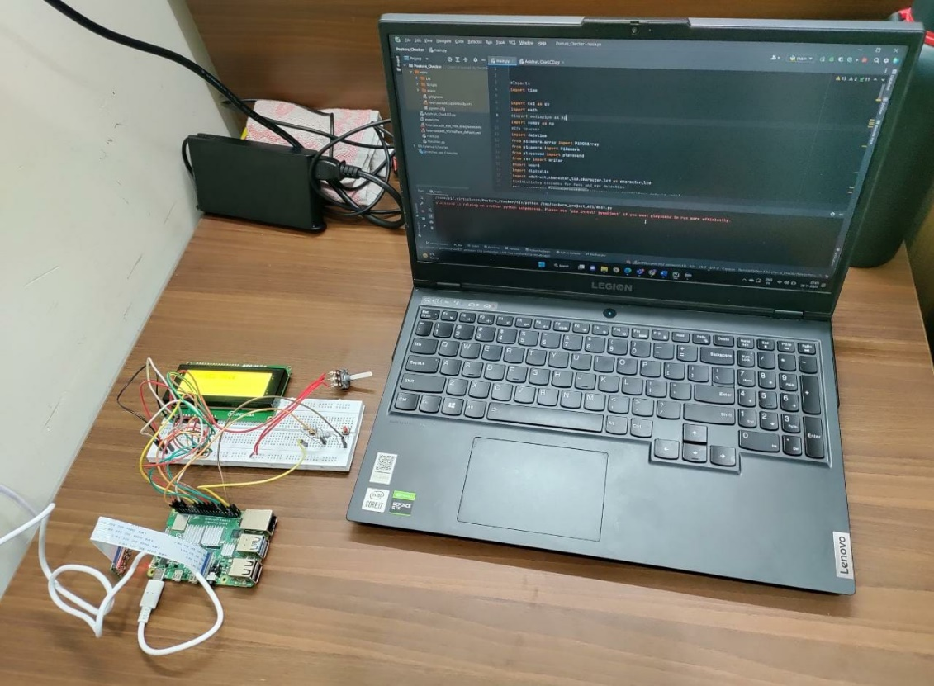

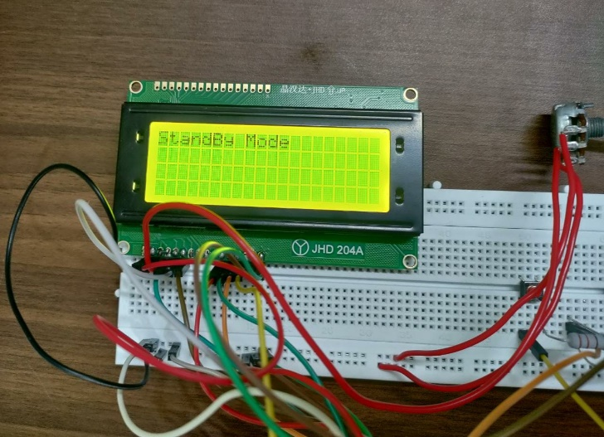 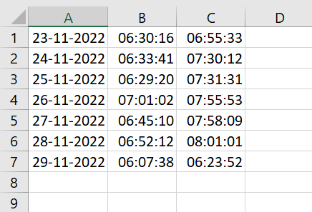

## 5. CONCLUSION AND FUTURE SCOPE

5.1)The project helps the users avoid distractions by replacing the basic functionalities of the phone helping them fully focus on their studies. It helps in correcting the posture of the user and helping them sit for long hours with a lesser physical strain. Parents and students have the ability to track the data of the studying session helping them to improve the studying experience. Thus the users can improve the productivity and quality of their studying experience with the help of this project.

5.2) Further this project can be improved with the help of an app that can display data of the users with the help of infographics. The project can be integrated with a more interactive and bigger display with visual graphics enhancing the studying experience. A speaker can be integrated to play the warnings and other sound outputs. An AI voice assistant can be added to provide commands and interact with the device.

## 6. REFERENCES

6.1) Set up buttons and switches on raspberry pi-Circuit Basis

<https://www.circuitbasics.com/how-to-set-up-buttons-and-switches-on-the-raspberry-pi/>

6.2) Camera Installation

<https://picamera.readthedocs.io/en/release-1.13/install.html>

6.3) Raspberry Basics

<https://www.youtube.com/watch?v=2RHuDKq7ONQ>

6.4) LCD display Connections

6.4.1) <https://www.raspberrypi-spy.co.uk/2012/08/20x4-lcd-module-control-using-python/>

6.4.2) <https://www.instructables.com/How-to-Connect-16x2-Lcd-With-Raspberry-Pi/>

6.5) Raspberry Basics and its application

Ghael, Hirak. (2020). A Review Paper on Raspberry Pi and its Applications. 10.35629/5252- 0212225227

6.6) 20x4 Display Basics and its applications

Mamun, Abdullah & Alamgir, Mr. Fakir Mashuque. (2017). Flex Sensor Based Hand Glove for Deaf and Mute People. International Journal of Computer Networks and Communications Security. 5. 11.